PRACTICAL SUMMATIVE
ASSESSMENT
OUTCOME

Programme title | 118707 - Occupational Certificate: Software Developer
Assessment name/Module | PM-01-PS01 Electronic Communication
Module Code | 251201-005-00-PM-01
NQF Level | 4
Credits | 3

STUDENT NAME AND SURNAME: | Jayden Wilson
STUDENT ID NUMBER: | 0803045475081
SIGNATURE: | 
ASSESSMENT DATE: | 17/03/2026
ASSESSMENT VENUE | Curro Holdings Private College – Cape Town
ASSESSOR FEEDBACK:
ASSESSOR’S SIGNATURE & DATE:
STUDENT ASSESSMENT FEEDBACK:
STUDENT FEEDBACK DATE:
MODERATION DATE AND SIGNATURE
MARKING SUMMARY
 |  |  |  |  |  | TOTAL MARK | MARK |  |  | IAC
Task 1 |  |  | PA101 |  |  |  |  |  |  | IAC0101
1. |  |  | Internet & Web Usage |  |  | 4
2. |  |  |  |  |  | 2
3. |  |  |  |  |  | 4
4.. |  |  |  |  |  | 10
Task total |  |  |  |  |  | 20
Task 2 |  |  |  |  |  |  |  |  |  |  |  | IAC0101
1. | Electronic Mail |  |  |  |  | 3
2. |  |  |  |  |  | 5
3. |  |  |  |  |  | 2
4 |  |  |  |  |  | 5
Task total |  |  |  |  |  | 15
Task 3 |  | PA0101
1. |  | – Internet Forums & Discussion Boards |  |  |  | 5 |  |  |  |  | IAC0101 & IAC0102
2. |  |  |  |  |  | 5
3. |  |  |  |  |  | 5
Task total |  |  |  |  |  | 15
Task 4 |  |  |  | PA0101
1. |  |  |  | Digital Learning Platform |  | 5 |  |  | IAC0101 & IAC0102
2. |  |  |  |  |  | 5
Task -total |  |  |  |  |  | 10
Task 5 |  |  |  |  | PA0101
1. |  |  |  |  | Virtualization and Virtual Meeting | 2 |  | AC0101 & IAC0102
2. |  |  |  |  |  | 6
3. |  |  |  |  |  | 5
4. |  |  |  |  |  | 12
Task -total |  |  |  |  |  | 25
Final Mark |  |  |  |  |  | 85

PRACTICAL SUMMATIVE ASSESSMENT: PM01PS01
Instructions
- Candidates must complete all tasks and achieve an overall proficiency of 80% to be considered competent in this component.
- Candidates are required to submit their own original and authentic work.
- Candidates will be granted three additional assessment opportunities and will only need to resubmit the sections where competence was not achieved.
- The assessment duration is 2 hours

General Summative Assessment Rules
- Candidates are only allowed to use the supplied Practical Summative Assessment Templates.
- Candidates are only allowed to use the black pen/colour for their answers.
- Candidates to ensure all their personal details appear on the front cover page.
- Candidates to ensure that they read the questions carefully and answer only what has been asked.
- In case of a written assessment, write clearly and use both sides of the paper but leave the margins free for use of the assessor.
- No explanation of the Practical Summative Assessment questions may be asked or given.
- As soon as their Integrated Summative Assessment answer books have been handed in/ submitted, candidates must leave the assessment room, but candidates will not be allowed to leave the assessment room less than one hour after the stipulated time of commencement of the examination.
- Candidates may not aid or attempt to aid each other, not obtain, or attempt to obtain aid, nor communicate or attempt to communicate with anyone.
- No disturbance maybe be created in the assessment room and candidates may not conduct themselves in an improper or unseemly manner.
- The instructions or directives of the invigilators may not be disregarded.
- Unless otherwise laid down for an examination, no books, memoranda, notes, maps, photographs or other documents or paper including (unused paper) or other aids pertaining to Summative Assessment Module. Except for that which is supplied and of admission permits, may be in the examination room: Provided that slide rules, pocket calculators and other aids maybe used in the examination expect in cases where a notice prohibiting their use appears on the question. The use of cell phones is strictly prohibited.
- If these instructions are contravened candidates expose themselves to disqualification from future Summative Assessments, and the Assessment Officer can in such a case refuse to give credit for answers.
- Anyone who commits an act directed at gaining or giving a candidate any unfair advantage is guilty of an offence.

Declaration: Assessment Readiness

I……………………………………………………………………………………………. (Learner) herewith declare that: I am ready for the assessment, that we have reviewed the assessment preparation and plan, I understand the assessment process, and I am happy that the assessment will be conducted in a fair manner.

Learner signature: | Date:
 | 17/03/2026

LEARNER DECLARATION OF AUTHENTICITY
I, the undersigned learner, hereby declare that:
- I understand the assessment process and requirements.
- I confirm that the work submitted is entirely my own.
- I have not received or provided any unauthorized assistance.
- I understand that plagiarism or misconduct may result in disqualification.
- I confirm that the assessment was conducted in a fair and transparent manner.
Learner Full Name: ___________________________________________
Learner ID Number: ___________________________________________
Signature: _________________________________________________
Date: _______________________________________________________

Purpose
This assessment evaluates your ability to use computer technology effectively as a communication and information tool. You will demonstrate applied knowledge in internet usage, electronic mail, forums, digital learning, and virtualisation

Internal Assessment Criteria
IAC0101: The use of computer technology as a communication tool is demonstrated
IAC0102: The use of and accessing the internet, websites, electronic email, internet forums, digital learning and virtualisation is demonstrated

- PA0101 Demonstrate the use of various functionalities:
  - Internet
  - Web sites
  - Internet service providers
  - Electronic mail
  - Internet forums
  - Digital learning
  - Virtualisation (e.g. virtual meetings, virtual workshops, conferencing, etc.)
Learner Instructions
- Complete all tasks in this assessment. Marks will be awarded for accuracy, completeness, and correct use of technology.
- Save and submit evidence of your work where requested (screenshots, links, exported reports, or shared access to documents).

ASSESSMENT TASKS

Task 1: Internet & Web Usage | 20 marks
IAC0102 The use of and accessing the internet, websites, electronic email, internet forums, digital learning and virtualization is demonstrated
AK0101 Various electronic applications

- ISP Identification: Open your CMD. Use the command tracert 8.8.8.8 to Identify and write down the details of the Internet Service Provider (ISP) currently providing your connection.
- IP address and URL  url: vc-gp-n-105-242-208-81.umts.vodacom.co.za  IP: [105.242.208.81] | (4 marks)
- Website Navigation: Open a web browser (e.g., Chrome, Edge). Navigate to career website (e.g., https://roadmap.sh/) | (4 Marks)
- Describe one key feature of the website  A key feature of this website is it’s readability. The purpose and goal of the website is easy to follow and navigation over the website is simple | (2 marks)
- Choose your ideal career and provide a screenshot, in the relevant section

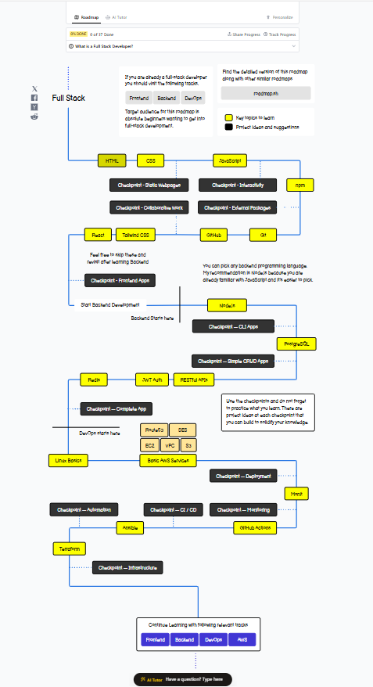

- Evidence: Submit screenshots of the tracert result and the ideal career. 5 marks per screen short | (10 Marks)
Type answer here and Insert screenshots here

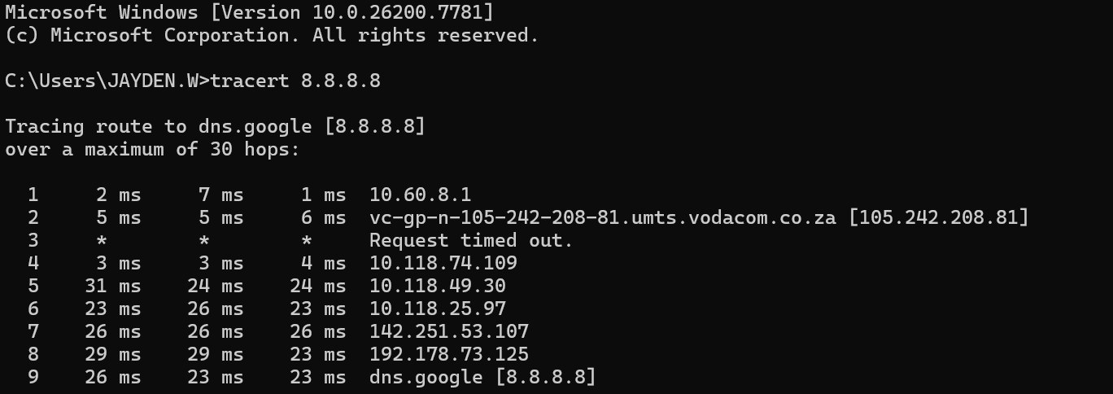



Task 2: Electronic Mail | 15 marks
IAC0101: The use of computer technology as a communication tool is demonstrated
- Compose an email to the assessor or instructor with the subject line:  “Practical Assessment Submission – [Your Name]” | (3 Marks)
- Include the following in the email body:  - Your full name  - The date  - A summary of your learning experience with online platforms | (5 Marks)
- Send the email to your Facilitator and verify that it appears in your "Sent" folder. | (2 Marks)
- Use the print to PDF feature and insert a screenshot of your sent email | (5 Marks)
Insert your screen shot here

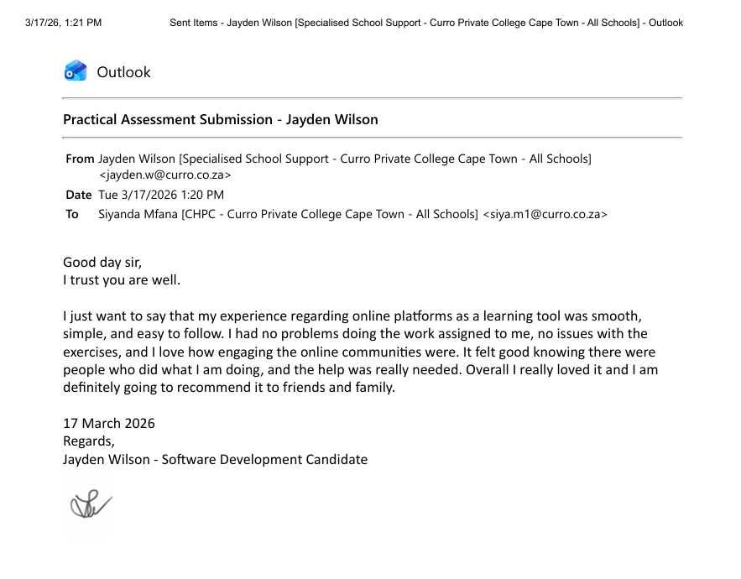

Task 3: Internet Forums & Discussion Boards | 15 Marks
IAC0102: The use of and accessing the internet, websites, electronic email, internet forums, digital learning and virtualisation is demonstrated
- Internet Forums: Navigate to professional internet forum Stack Overflow. Find discussion thread related to "HTML" or "Javascript" | (5 Marks)
insert Screen shot here

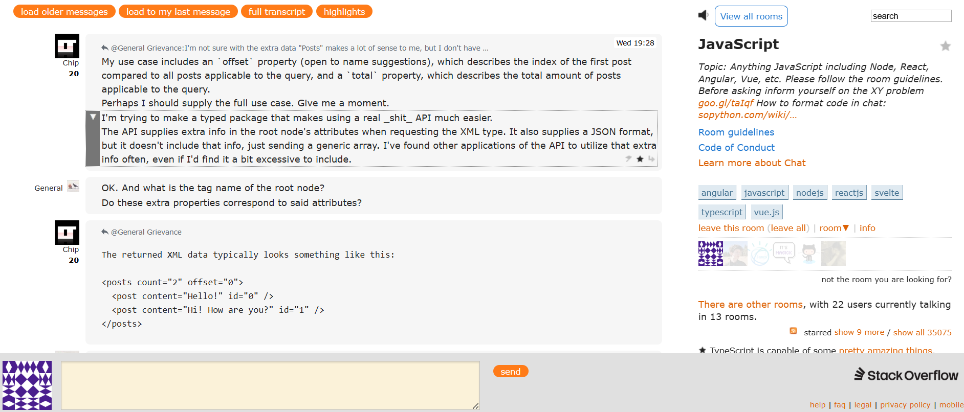

- Participation: Summarize the main point of one forum post in a text document. | (5 Marks)
Type your answer here
The main point of a forum post is to ask a question publicly and hope to receive a response publicly. Also, so that people who run into a problem like the one you are in right now can find a solution more easily. You can see the time when people posted an answer to the post and also you are able to follow along the thread, maybe you can see different approaches to a question and see how people engaged upon them. You also gain credit based on how many people agree with your post and therefore you become more recognized on the platform and you become more credible.
- Explain how Stack Overflow facilitates the exchange of knowledge amongst professionals. | (5 Marks)
Type your answer here
Professionals use this platform to answer questions; they can also practice with the code from people who are asking questions and everybody learns from each other. Professionals can review each other’s code and therefore comment, criticize and give feedback to each other. Newer professionals can receive advice from more experienced professionals.

Task 4: Digital Learning Platform | 10 marks
IAC0102: The use of and accessing the internet, websites, electronic email, internet forums, digital learning and virtualisation is demonstrated
- Log-in to Moodle. Click on the Menu tab “My Courses” and take a screenshot of your course enrolment. | (5 Marks)
insert Screen shot here

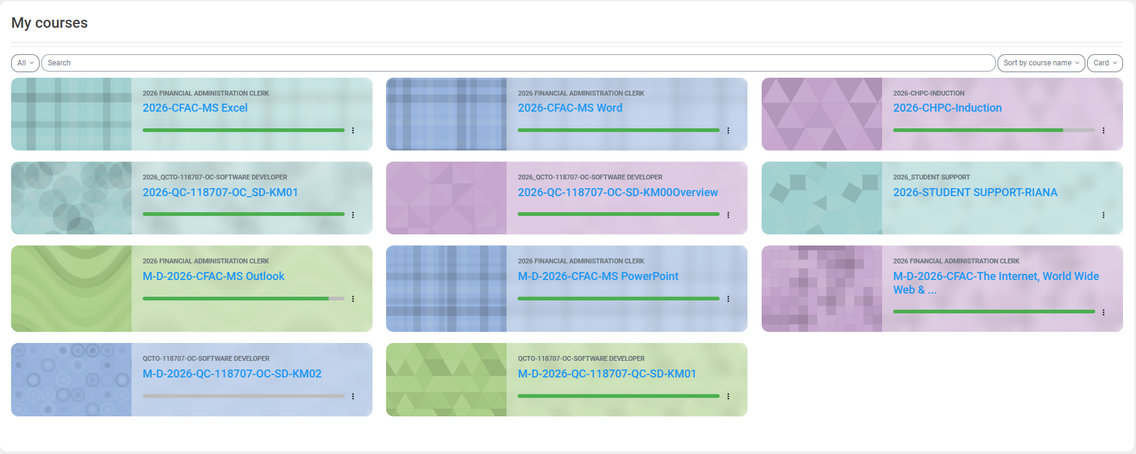

- Course Navigation: Locate a specific module or introductory video. Take a screenshot of your KM01 completion status, making sure you display that you are the logged in user. | (5 Marks)
insert Screen shot here
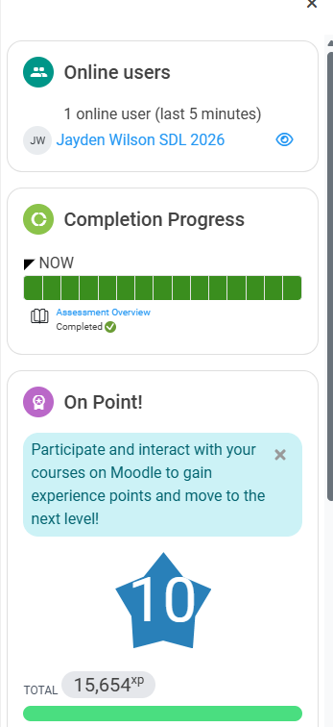

Task 5: Virtualization and Virtual Meetings (25 Marks) (IAC0102, PA0101 | 25 Marks
IAC0102: The use of and accessing the internet, websites, electronic email, internet forums, digital learning and virtualisation is demonstrated
- Meeting Scheduling: Open a virtualization application (e.g., Zoom, Google Meet, or Microsoft Teams). | (2 Marks)
- Create an Event: Schedule a "Virtual Workshop" for tomorrow at 10:00 AM. Ensuring you invite at least 1 participant. | (6 Marks)
- Meeting Invite: Copy the meeting link and paste it into the text document created in Part 2  Virtual Workshop | Meeting-Join | Microsoft Teams  https://teams.microsoft.com/meet/34907956594079?p=sUaAeoBjGMlsXqkMJm | (5 Marks)
Insert screenshot here
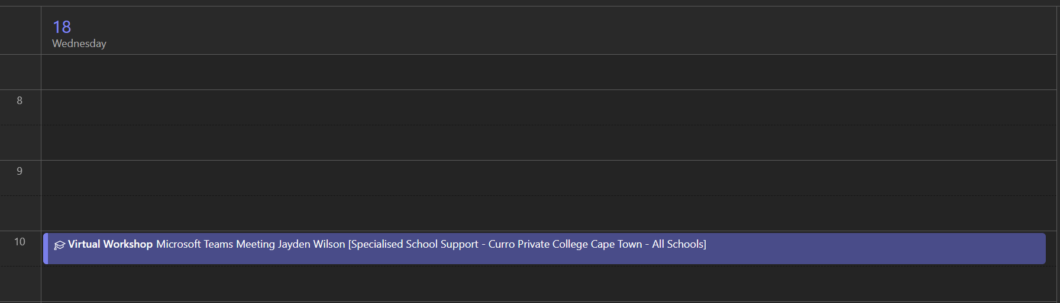

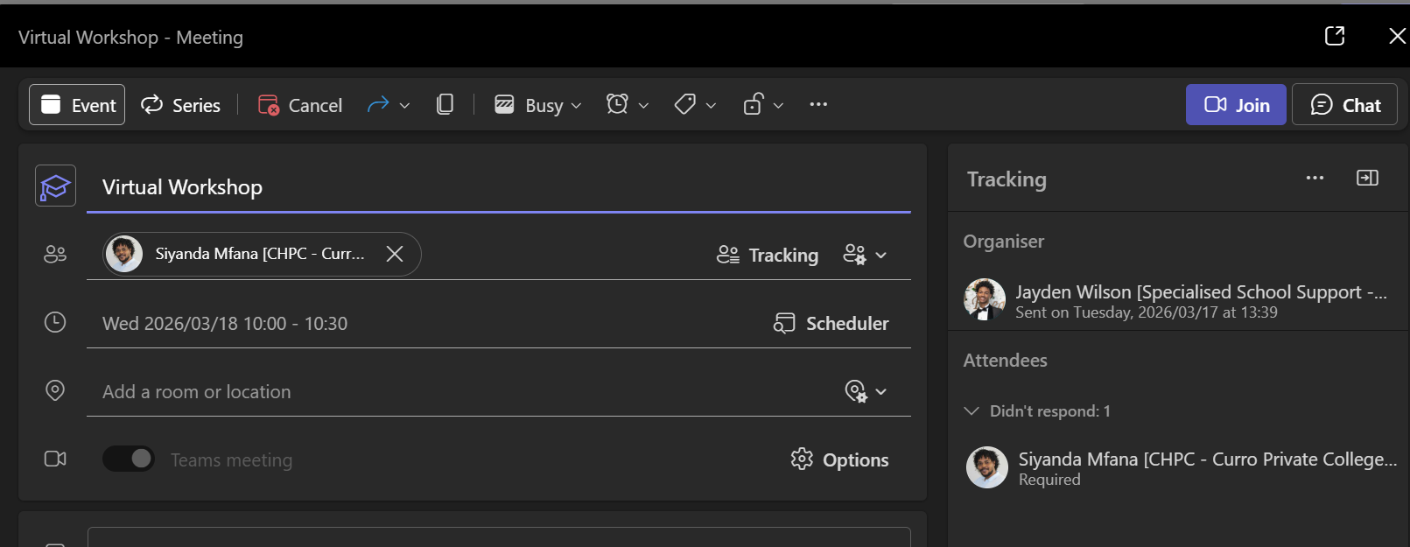
- Functionality: Demonstrate the following during a live or simulated meeting:
4.1 Muting and unmuting your microphone - | (2 Marks)
Type response/Insert screenshot here
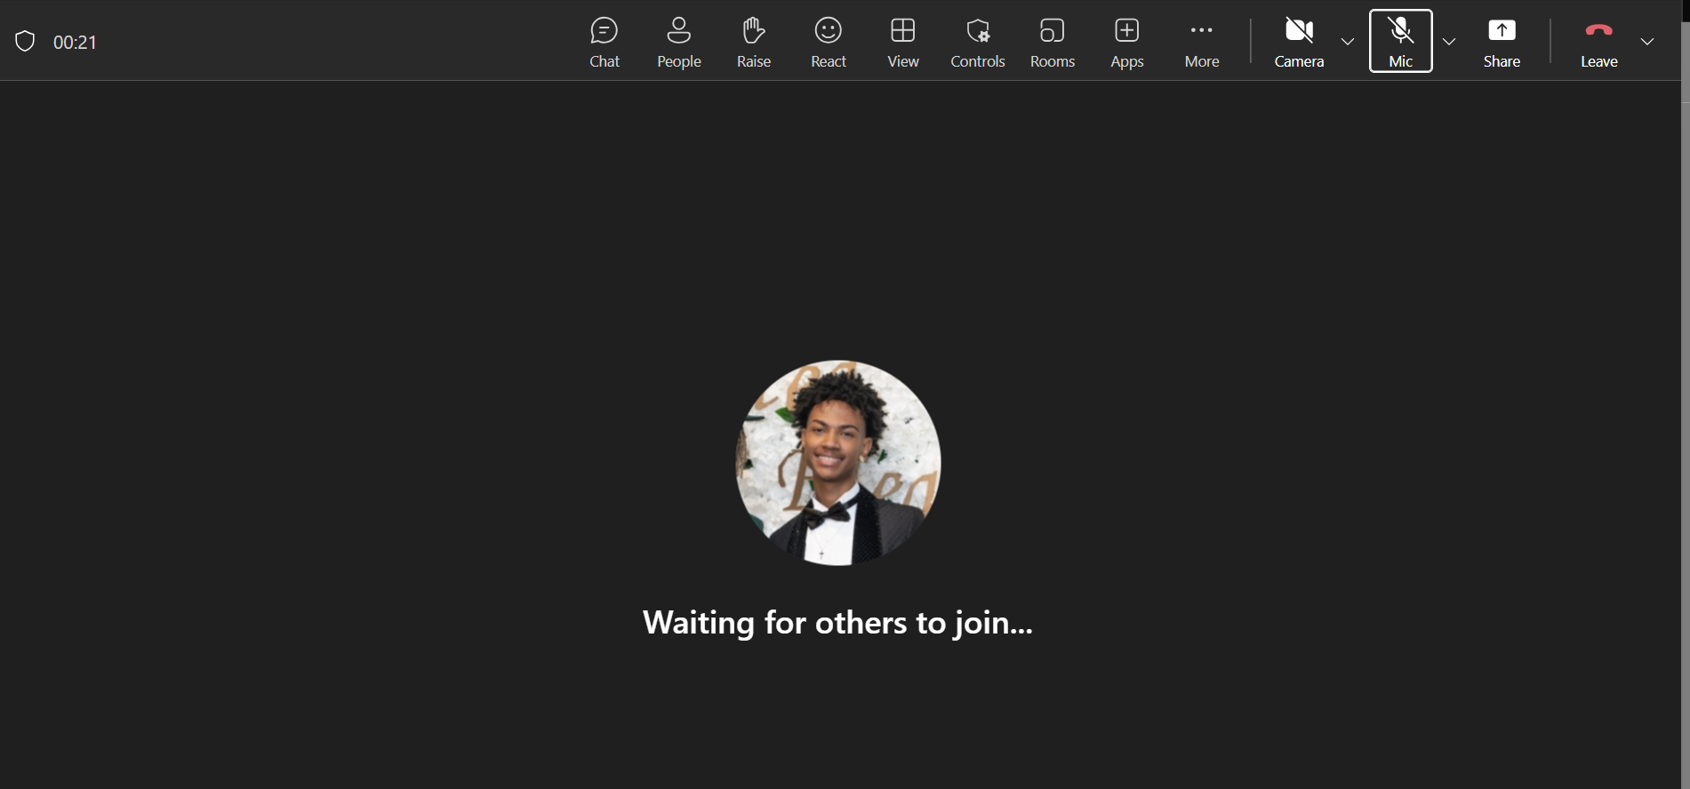
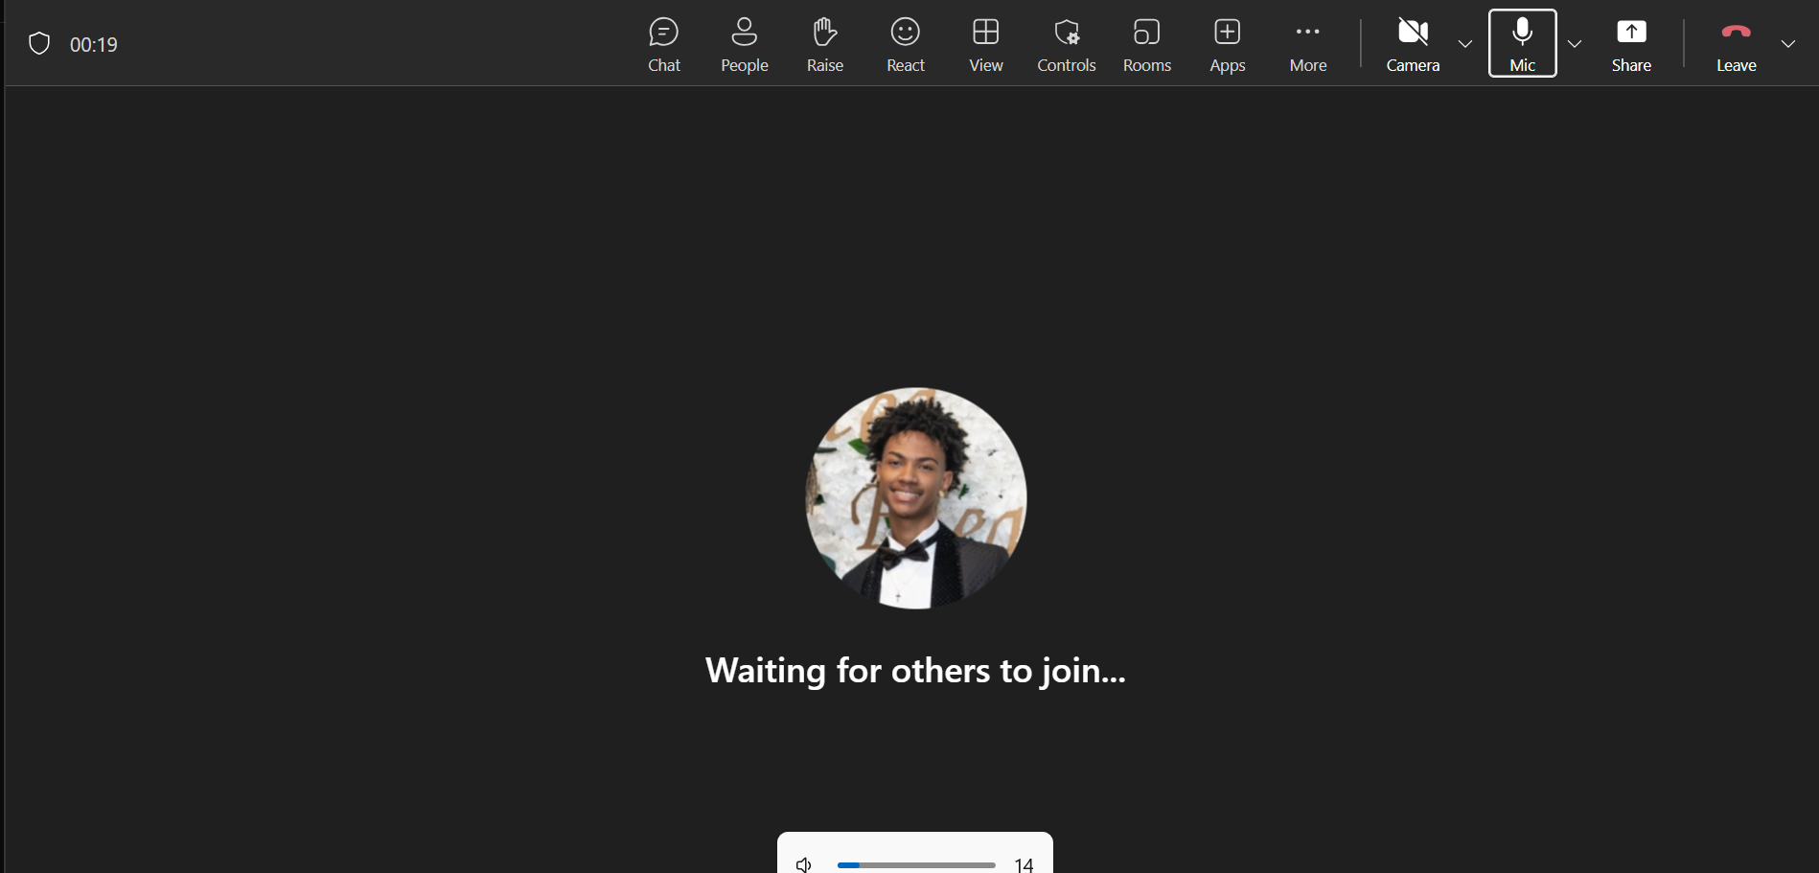

4.2 Turning your camera on and off - | (2 Marks)
Type response/Insert screenshot here
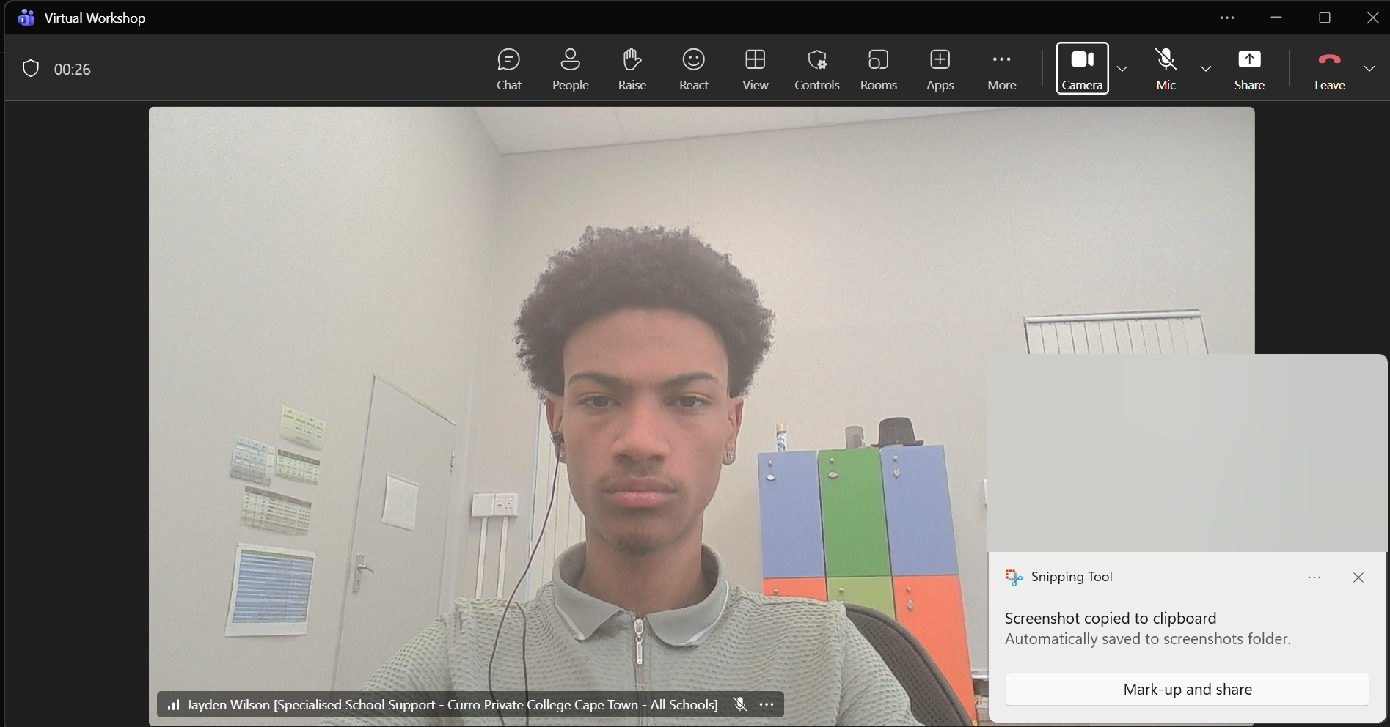
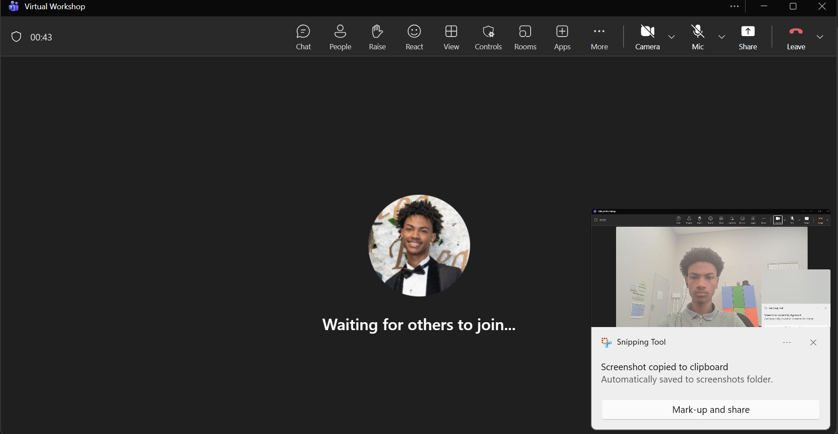

4.3 Using the "Chat" function to send a message to participants. - | (4 Marks)
Type response/Insert screenshot here
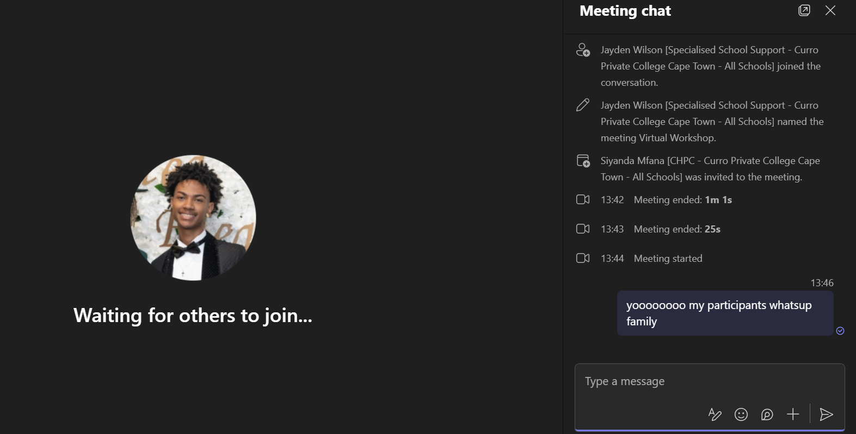

Using the "Share Screen" function to show your saved practical folder. | (4 Marks)
- Type response/Insert screenshot here
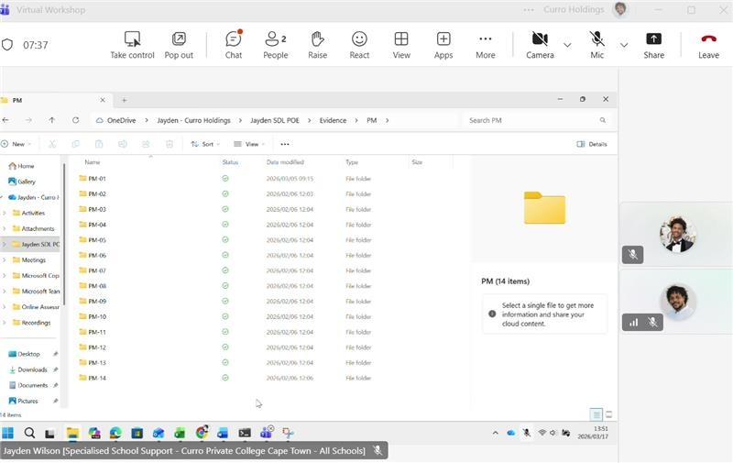

Total Marks – 25

